We have a dominant leadership style:
Task-motivated
Satisfaction gained from task accomplishment
Relationship-motivated
Satisfaction from forming and maintaining relationships
To determine, you must use the Least Preferred Coworker (LPC) scales
There is no wrong style, use the style that best fits the situation
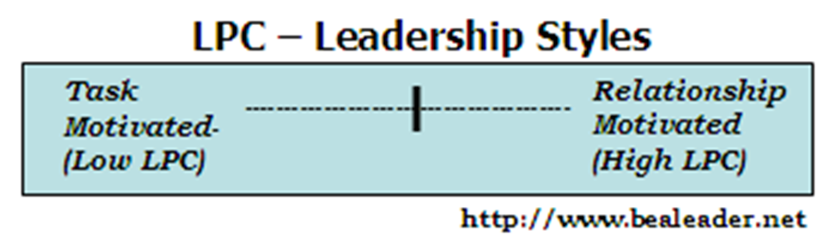
Situational Favourableness
Matching the LPC style to the situation
How much a situation allows the leader to exert influence over the followers

There are three variables in situational favourableness:
Leader Member-relations-
Most powerful determinant
The better the relations, the more favourable the situation
Task Structure-
Second importance
Is the task structured or unstructured?
Leaders in structured situations have more influence
The more structured
the job, the more
favourable the situation
Position Power-
Does the leader have power to assign work, reward and punish, hire and fire, give raises and promotions?
The more position power,
the more favourable the situation
The weight of these three factors together create a continuum of situational favourableness of the leader (Fiedler developed 8 levels: 1 highly favourable to 8 very unfavourable)
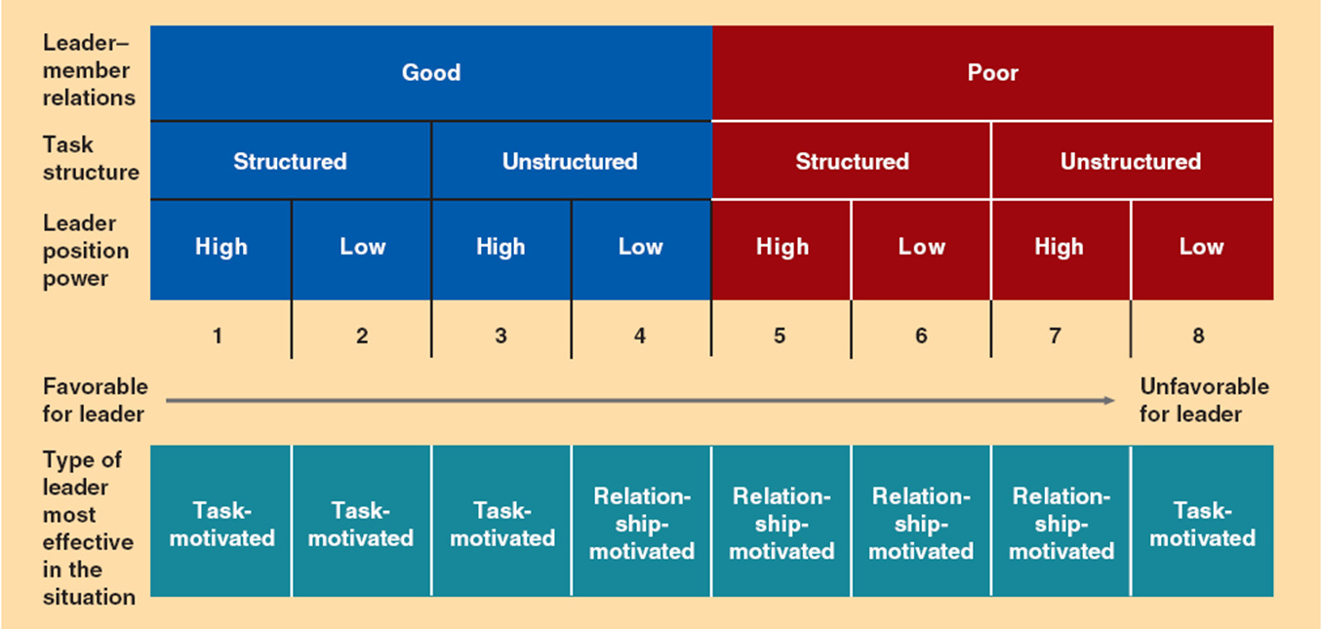
Lussier, Robert N., and Christopher F. Achua. Leadership: Theory, Application, & Skill Development,. Mason, OH: South-Western Cengage Learning, 2010. Print.
After answering the questions, if the LPC leadership style matches, the user does nothing since they may be successful in the situation
To change certain situations:
Poor relations?
Take interest in followers and spend more time listening to them and getting to know them
A task can be more or less structured by:
Stating more or less specific standards and procedures for completing a task
Leader with strong position power:
Can downplay his power
Leader with weak position power:
Ask for more power from their manager and play up the power
Research, Criticisms and applications:
Fielder believes we should change the job context as appose to style
It is easier to change style than job context
Fielder doesn’t show how to change job context
Doesn’t explain how a leader’s LPC score affects group performance
The model neglects medium LPC scores It only considers High and Low LPC leaders, while most of the leader exhibit a medium LPC score
Path-Goal Leadership theory and model:
Definition:
“The path-goal leadership model is used to select the leadership style (directive, supportive, participative, or achievement oriented) appropriate to the situation (subordinate and environment) to maximize both performance and job satisfaction.”
The leader is responsible for increasing the followers’ motivation to reach personal and organizational goals
Motivation is increased by:
Clarifying the follower’s path to the rewards available
Increasing the rewards that the follower wants
Situational Factors:
Subordinate
Environment
Subordinate:
Authoritarianism
How much employees want to be told what and how to do the job
Locus of control
How much employees believe they control their goal achievement or if it’s controlled by others
Ability
Extent of the employee’s ability to perform tasks to achieve goals
Environment:
Task structure
Extent of repetitiveness of the job
Formal authority
Extent of the leader’s position power
Work group
The extent to which coworkers contribute to job satisfaction or the relationship between followers
Leadership Styles:
Once the situation is determined, the Path-goal model is used to determine employee objectives and clarify how to achieve them using one of four leadership styles
Directive
Supportive
Participative
Achievement-oriented
Directive:
Leader provides high structure
Appropriate to use:
When followers ability is low
When environmental task is complex
Formal authority is strong
Supportive:
Leader provides high consideration
Appropriate to use:
When follower ability is high
When followers do not want a lot of leadership
When environmental task is simple
Formal authority is weak
Participative:
Leader includes employee input into decision making
Appropriate to use:
When follower ability is high
When followers want to be involved
When environmental task is complex
Authority is neither weak nor strong
Achievement oriented:
The leader sets difficult but achievable goals
Expects followers to work their hardest and rewards them when they do
Leader provides both high directive (structure) and high supportive (consideration) behavior
Appropriate to use:
When follower ability is high
When the environmental task is simple
Authority is strong
Research, criticism & applications:
It is difficult to know which style to use when
Path-goal is an effective way for leaders to think about motivating followers
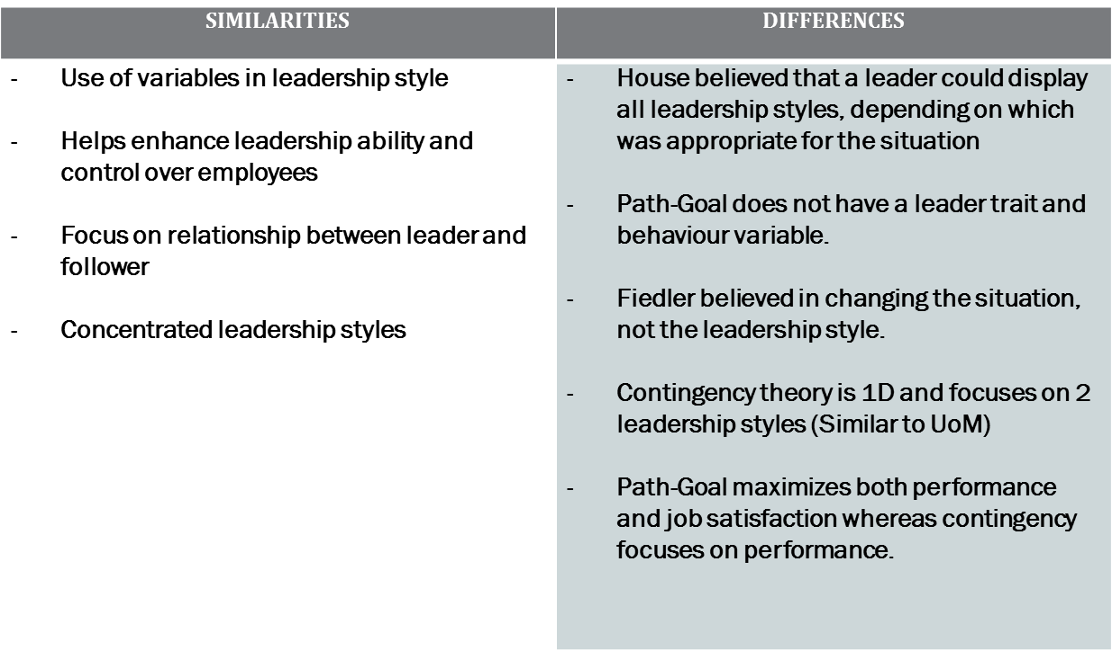
Lussier, Robert N., and Christopher F. Achua. Leadership: Theory, Application, & Skill Development,. Mason, OH: South-Western Cengage Learning, 2010. Print.

